**BabyCare**

Submitted in partial fulfillment of the requirements of

**E Diploma in Advanced Computing**

By

**Swapnil Supekar 200940381118**

**Ekta Walavalkar 200940581006**

**Shubham Dhawale 200940381099**

**Shital Patil 200940381094**

**Vikash Shukla 200940381129**

**Kamlesh Singh 200940381036**

Guide(s):

**Mr.Rohan Rakhunde,Mr.Kiran Ulgmude**

Project Guide

**Mr. Abhijeet Wagh**

Faculty,Cdac Mumbai



**Centre for Development of Advanced Computing**

**Kharghar/Juhu**

**September 2020**

**CERTIFICATE**

This is to certify that the project entitled **“BabyCare”** is a bonafide work of **“Swapnil Supekar (200940381118),Ekta Walavalkar(200940581006),ShubhamDhawale(200940381099),Shital Patil(200940381094),Vikash Shukla (200940381129), Kamlesh Singh(200940381036).”** submitted to C-DAC Mumbai in partial fulfillment of the requirement for the award of the E-Diploma in Advanced Computing.

**Mr.Rohan Rakhunde & Mr.Kiran Ulgmude**

**Mr.Abhijeet Wagh**

**Supervisor/Guide Faculty Supervisor/Guide**

Declaration

I declare that this written submission represents our ideas in our own words and where others' ideas or words have been included, we have adequately cited and referenced the original sources. We also declare that we have adhered to all principles of academic honesty and integrity and have not misrepresented or fabricated or falsified any idea/data/fact/source in my submission. We understand that any violation of the above will be cause for disciplinary action by the Institute and can also evoke penal action from the sources which have thus not been properly cited or from whom proper permission has not been taken when needed.

-----------------------------------------

( Swapnil Supekar 200940381118)

-----------------------------------------

( Ekta Walavalkar 200940581006)

-----------------------------------------

( Shubham Dhawale 200940381099)

-----------------------------------------

( Shital Patil 200940381094)

-----------------------------------------

( Vikash Shukla 200940381129)

-----------------------------------------

( Kamlesh Singh 200940381036)

Date:26/03/2021

**Abstract**

A software product which provides solution for baby health, baby tips, baby products,Doctors, Vaccination centers,babysitters etc.It provides Home Services On Demand by Providing only verified and high quality professional.One stop for baby care.The idea is to help people find the best services easily and provide the large base of individuals and small businesses and healthcare professionals with a platform to manage and grow their client network.BabyCare Management System is a platform that aims to effortlessly connect and serve a large local base of individuals with healthcare professionals.

The main scope of this project is to provide Childcare Services at your ease and also on your doorstep, by providing trusted quality products and professionals .One stop for all your baby’s care.Our aim is to connect customers to professionals with ease ,also providing required healthcare products at their doorstep.

**Contents**

|  |  |  |
| --- | --- | --- |
| **Chapter** | **Contents** | **Page No.** |
| **1** | **INTRODUCTION:** Give at least two to three sentences about your project. | **9** |
|  | **1.1 Description *(Brief description of project)*** The main functionality of the project should be explained in brief | **9** |
|  | **1.2 Problem Formulation *(Explain the problem)*** | **10** |
|  | **1.3 Motivation *(need of the project)***: List the various approaches along with its drawbacks for solving the problem and briefly explain the approach used for your project. | **10** |
|  | **1.3 Proposed Solution:** Explain the method/technique used for solving the problem and how it overcomes the drawbacks mentioned under heading 1.3. Also explain how the project is going to help end users. | **10** |
|  | **1.4 Scope of the project *(scale/range of your project)*:** Extent of how far your project can be completed. This can be in terms of domain or application related constraints/limitations. | **10** |
| **2** | **REVIEW OF LITERATURE *(include at least 3IEEE or similar reputed technical papers as reference or give reference sites and details of algorithms used*)** Should be atleast 2 pages which gives the ideas referenced by the reference papers. Mark the references wherever appropriate. (Note: - Please don’t write the paper titles and the abstract of papers.) | **11** |
| **3** | **SYSTEM ANALYSIS** | **12** |
|  | **3.1 Functional Requirements *( write requirements of the project)*** Should follow the IEEE SRS format | **12** |
|  | **3.2 Non Functional Requirements** Should follow the IEEE SRS format | **12** |
|  | **3.3 Specific Requirements *(Hardware and software requirements)*** | **13** |
| **4** | **ANALYSIS MODELING** | **15** |
|  | **4.1 Use-Case Diagrams and description**  **4.2 Activity Diagrams**  **4.3 Class Diagram**  **4.4 Sequence Diagram** |  |
| **5** | **DESIGN** | **22** |
|  | **5.1 Data Modeling *(E-R Model, Relational tables with its associated Data dictionary****)*  ER Diagram normalized till the third normal form accompanied by the respective data dictionary table should be included | **22** |
|  | **5.2 Architectural Design (*Project Flow /architecture* *with description)*** | **22** |
|  | **5.2 User Interface Design** GUI for your project | **29** |
| **6** | **IMPLEMENTATION** | **30** |
|  | **6.1 Algorithms / Methods Used**  Mention your algorithms if any or any methodology used. |  |
|  | **6.2 Working of the project *(code for mentioned algorithms) [do not copy paste entire code. Only main snippets]*** |  |
| **7** | **TESTING *(white box /black-box / any testing algorithm used)*** | **33** |
|  | **7.1 Test cases *(conditions on which testing is done)*** |  |
|  | **7.2 Type of Testing used *(explanation and reason of testing method used)*** |  |
| **8** | **RESULTS AND DISCUSSIONS *(final results or outputs)*** | **33** |
| **9** | **CONCLUSIONS & FUTURE SCOPE** | **34** |

Appendix

Literature Cited

Acknowledgments

**Chapter 1**

**Introduction**

The main idea of this project is to provide Childcare Services at your ease and also on your doorstep, by providing trusted quality products and professionals .One stop for all your baby’s care.Our aim is to connect customers to professionals with ease ,also providing required healthcare products at their doorstep.A software product which provides solution for baby health, baby tips, baby products,Doctors, Vaccination centers,babysitters etc.It provides Home Services On Demand by Providing only verified and high quality professional.

**1.1** **Description**

This project is a web application in which Admin ,users,doctors,babysitters can register on our portal or platform which will help them as well as customers or users to get in touch with each other and have their service get done. In our project there are different services including baby-names for your newborn child ,baby-care products ,babysitters if you need assistance,healthcare professionals such as doctors and finally we also have Vaccination centers listed on our portal which will help you find nearest services you require around you within no time.We have added a reminder as well as mail notification service in our system which will help you to connect with the healthcare professionals as well as the notification service will help you to get a reminder based on your service such as vaccination.

**1.2 Problem Formulation**

Finding the best healthcare is all we need for our newborn as so as to fulfill the requirement we came up with this idea which will connect users who are in search of healthcare services to the healthcare professionals directly.apart from that our platform is having different services including baby-names for your newborn child ,baby-care products ,babysitters if you need assistance,healthcare professionals such as doctors and finally we also have Vaccination centers listed on our portal which will help you find nearest services you require around you.

**1.3 Motivation**

With the increase of healthcare services and daily needs and products at doorstep as well as around us ,we need to know what services are nearby us to connect and get in touch with them at ease,That is why we came up with this idea of connecting Childcare professionals to the parents.

**1.4 Scope**

The main scope of this project is to provide Childcare Services at your ease and also on your doorstep, by providing trusted quality products and professionals .One stop for all your baby’s care.Our aim is to connect customers to professionals with ease ,also providing required healthcare products at their doorstep.

.

**Chapter 2**

**Review of Literature**

In today’s fast growing and busy world ,every parent looks for an easy convenient and at the same time professional healthcare and childcare service for their loved ones.Finding everything at one spot is the main thing which everyone looks for in today’s busy life.Providing trusted quality service was the main motto of babycare management system ,so we came up with this idea as our platform provides major facilities such as Healthcare professionals and vaccination services at one stop .At home, care is typically provided by [nannies](https://en.wikipedia.org/wiki/Nanny), [au pairs](https://en.wikipedia.org/wiki/Au_pair), or friends and family.The child is watched inside the home. This is done with a motive to avoid illnesses from outside interactions. Depending on the number of children in the home, the children utilizing in-home care could enjoy the greatest amount of interaction with their caregiver, in turn forming a close bond. There are no required licensing or background checks for in-home care, making parental vigilance essential in choosing an appropriate caregiver.

Nanny and au pair services provide certified caregivers and the cost of in-home care is the highest of childcare options per child, though a household with many children may find this the most convenient and affordable option. Many nannies study towards childcare qualifications. This training is intended to teach a carer how to create a safe and stimulating environment for children to enjoy and thrive in. Typically, au pairs or nannies provide more than routine child care, often providing assistance with daily household activities which include running errands, shopping, doing laundry, fixing meals, and cleaning the house.

The most now common way to find a healthcare services online on dedicated websites specializing in carer services, or through a nanny agency. Nanny agencies may provide a more thorough check of an applicant's references and run a criminal background check on the successful candidate.Depending on local prices for daycares, a nanny could be cheaper than putting multiple children in a daycare setting full-time. Proponents believe in-home care may provide stability for the child provided the same carer is retained over time. Nannies often work overtime and babysit. Some also care for sick children whereas nurseries typically do not. This enables the parents to continue working normally without being interrupted. Depending on local laws, some carers can be subject to visits from their local childcare regulatory bodies. Proponents also claim nannies could also be well socialized as nannies could be able to take them out and attend more playdates.

**Chapter 3**

**System Analysis**

## **3.1 Functional Requirements**

## **3.1.1 Login of Admin**

* + - * The Admin will be able to manage the Childcare Services.
      * The Admin will be able to add and delete babyname records.
      * The Admin/Manager will be able to add and delete healthcare professionals records.

## **3.1.2 Login of User**

* + - * The user will be able to get registered and login.
      * The user will be able to View and Book the appointment with the doctor, babysitters and vaccination centers.
      * The user will get notifications via E-mail
      * The user will be able to update his/her details.

## **3.1.3 Login of Doctor.**

* + - * The doctor will be able to manage the all the doctor services.
      * The doctor will be able to cancel appointments.
      * The doctor will get notifications via E-mail.
      * The doctor will be able to update his/her details.

# 

# **3.2 Non-functional Requirements**

## 3.2.1 Performance Requirements

The system should store all the database records of assigned project, assigned task, completed task, task status and requested task and the application should be available for use 24*7 through the server. Also, the application should be user friendly with a proper user interface which makes it easy for the user to understand. All the options should be present in properly accessible places for user convenience.

## 3.2.2 Safety Requirements

All login ids and passwords of the admin, managers and team leader and team members should be protected for privacy using whatever constraints required in the database or the application.

## 3.2.3 Security Requirements

All passwords of the administrators should be protected for privacy using whatever constraints required in the database or the application. Transactions regarding project manager and admin records should be carried out properly. The database should be protected from attacks and unauthorized access. The interface should be protected from attacks. All passwords should be stored as a secure hash of the administrator password.

## **3.3 Software Quality Attribute**

**3.3.1 Availability**

The system should run on a variety of operating systems that support the JavaScript language. The system should run on a variety of hardware.

## **3.3.2 Accessibility**

The software will be accessible to admin/ manager, user.

## **3.3.3 Compatibility**

The software will be compatible with multiple platforms.

## **3.3.4 Durability**

The software will be tested for working with multiple users.

## **3.3.5 Effectiveness**

The software will be made to handle operations effectively.

## **3.3.6 Maintainability**

The system should be easy to maintain. There should be a clear separation between the interface and the business logic code. There should be a clear separation between the data .

**Chapter 4**

**Analysis Modeling**

## **4.1 Use Case Diagram: -**

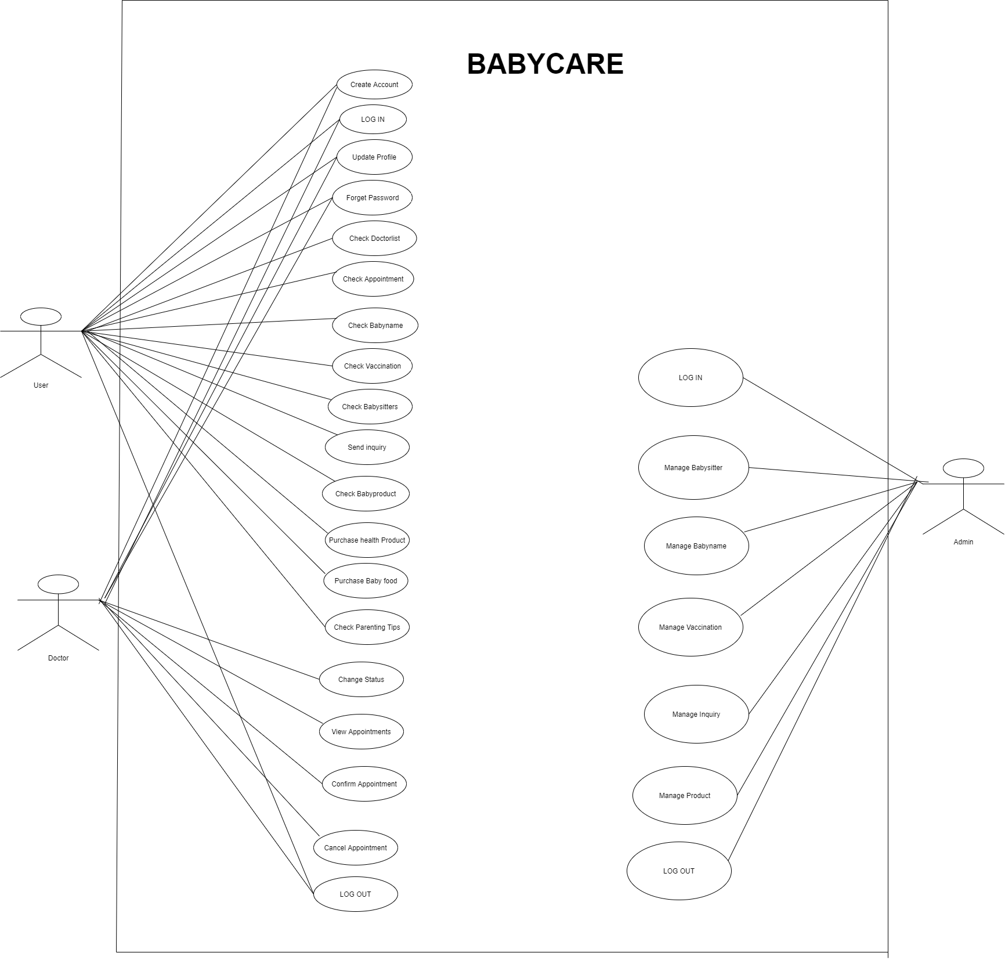

4.2 Class Diagram:

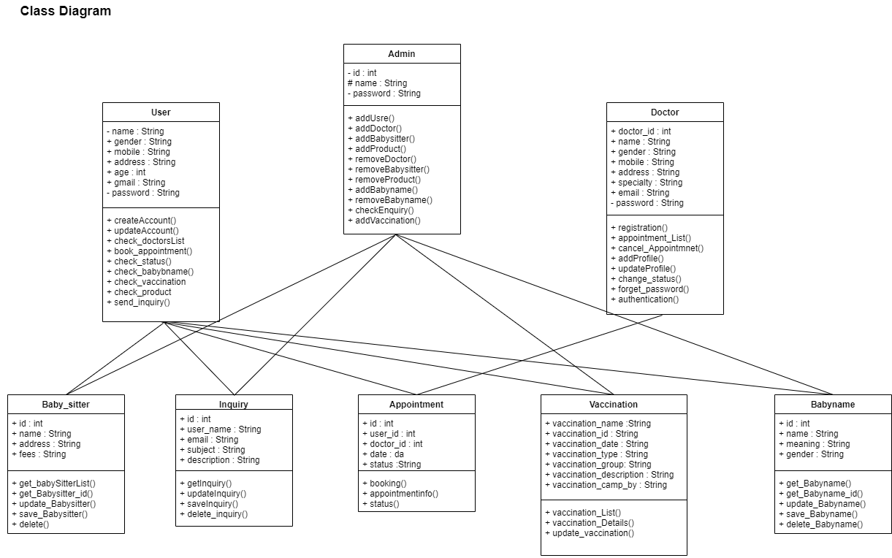

**4.3 Activity Diagram:**

4.3.1 Admin:

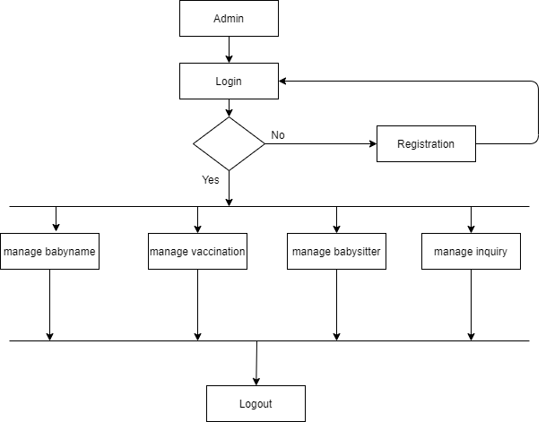

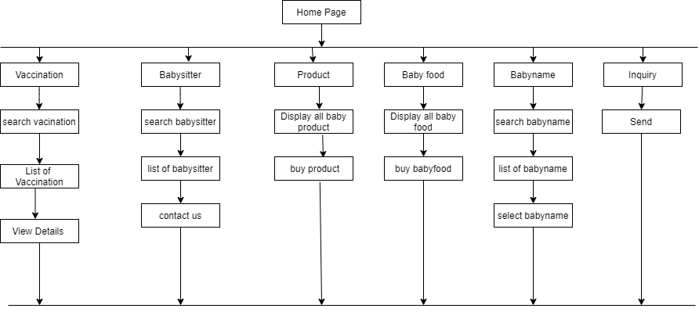

4.3.2 Homepage:

4.3.3 User:

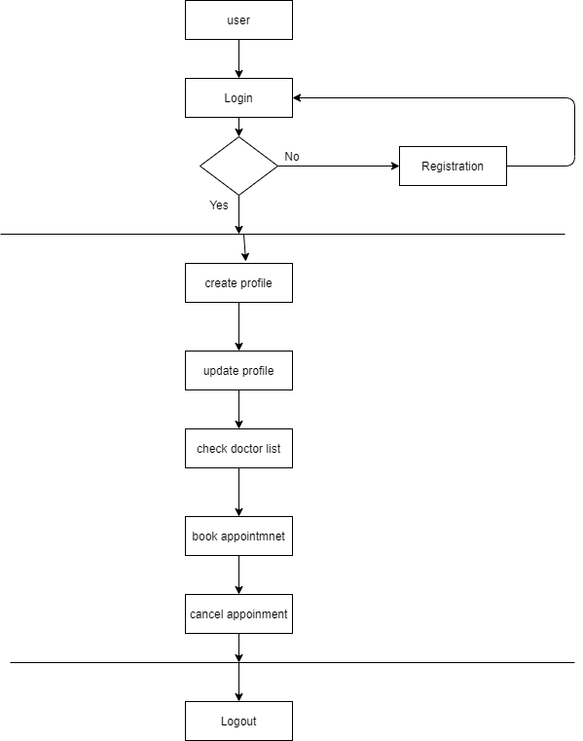

4.3.4 Doctor:

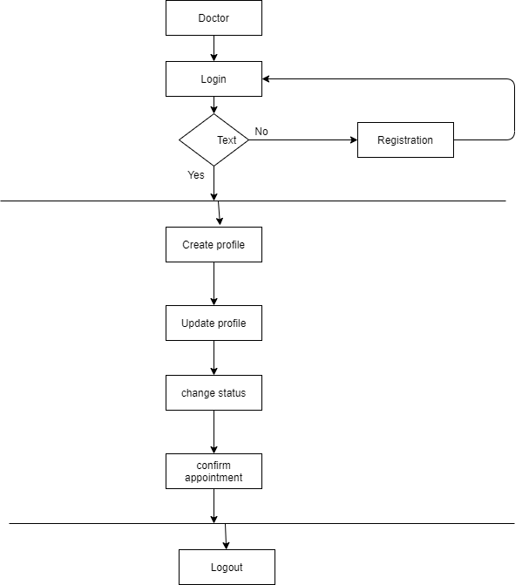

**4.4 Sequence Diagram**

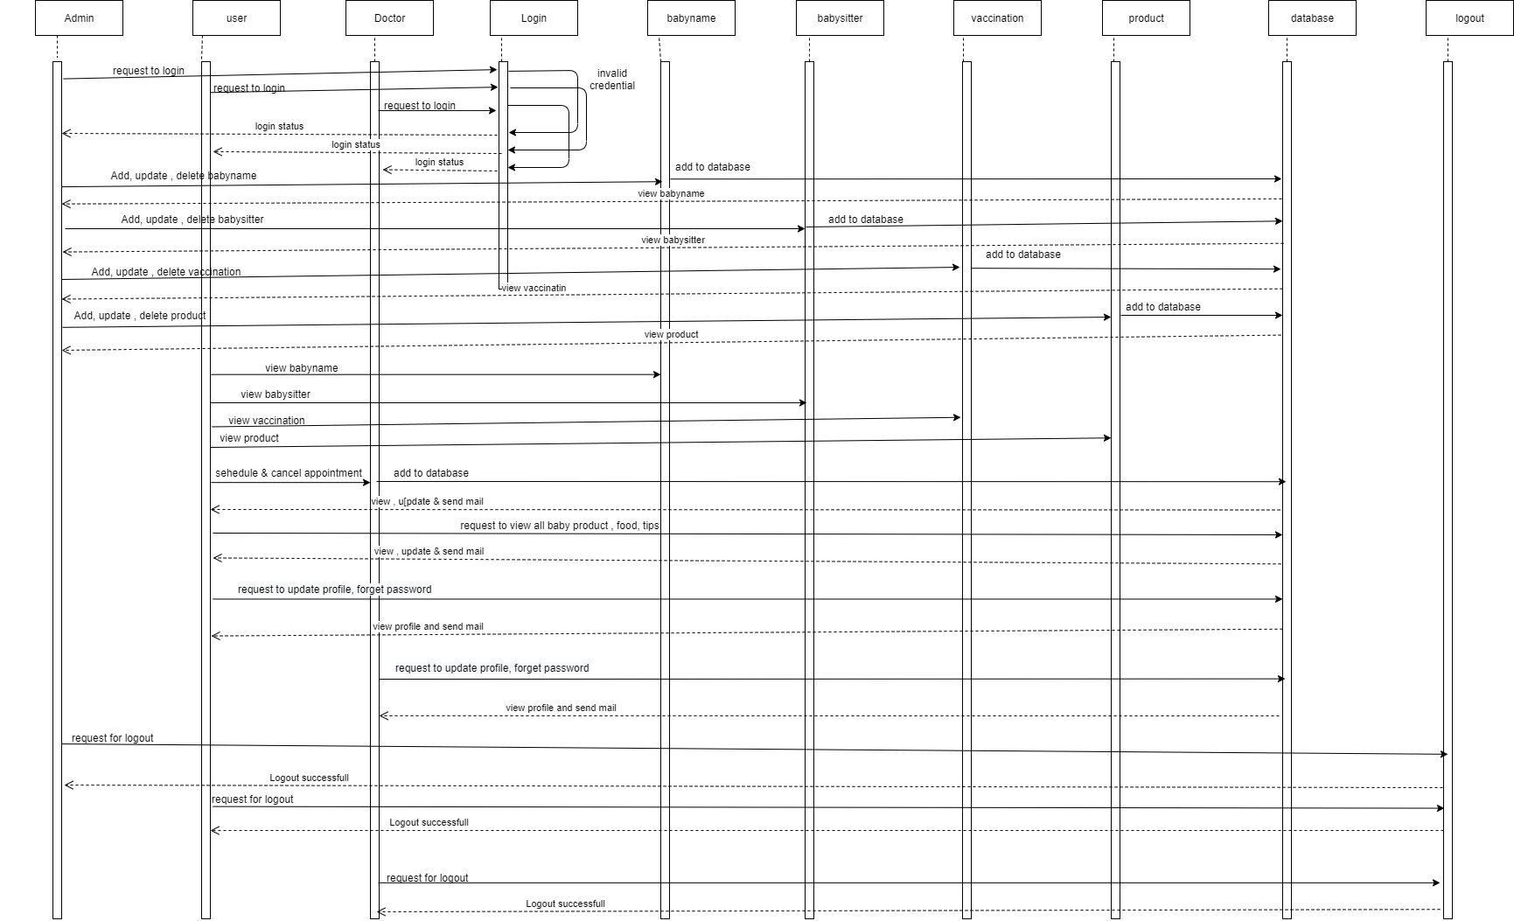

**Chapter 5**

**DESIGN**

**5.1 Data Modeling(ER Diagram):**

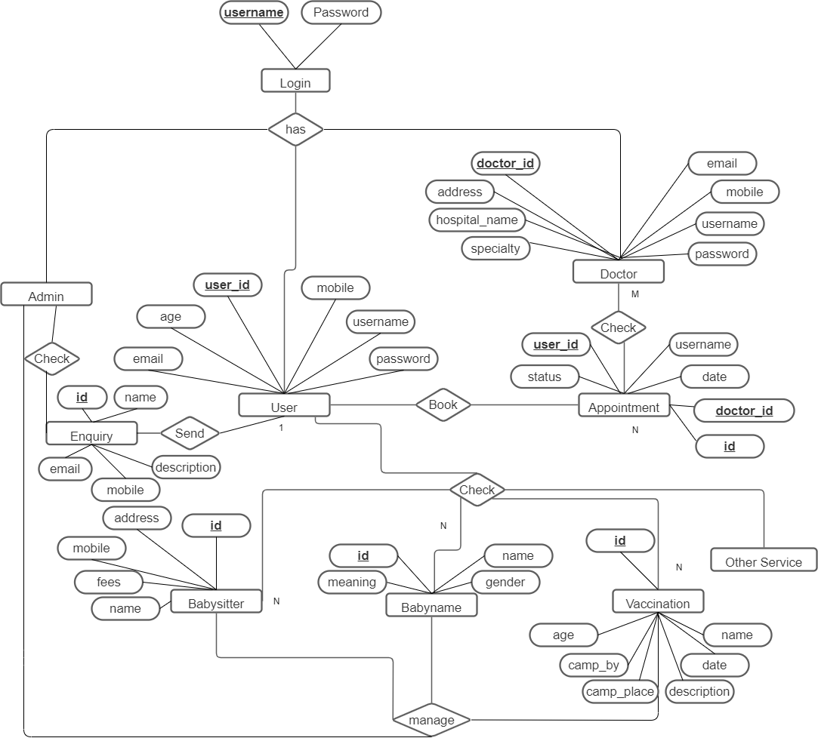

**5.2 User Interface Design(GUI):**

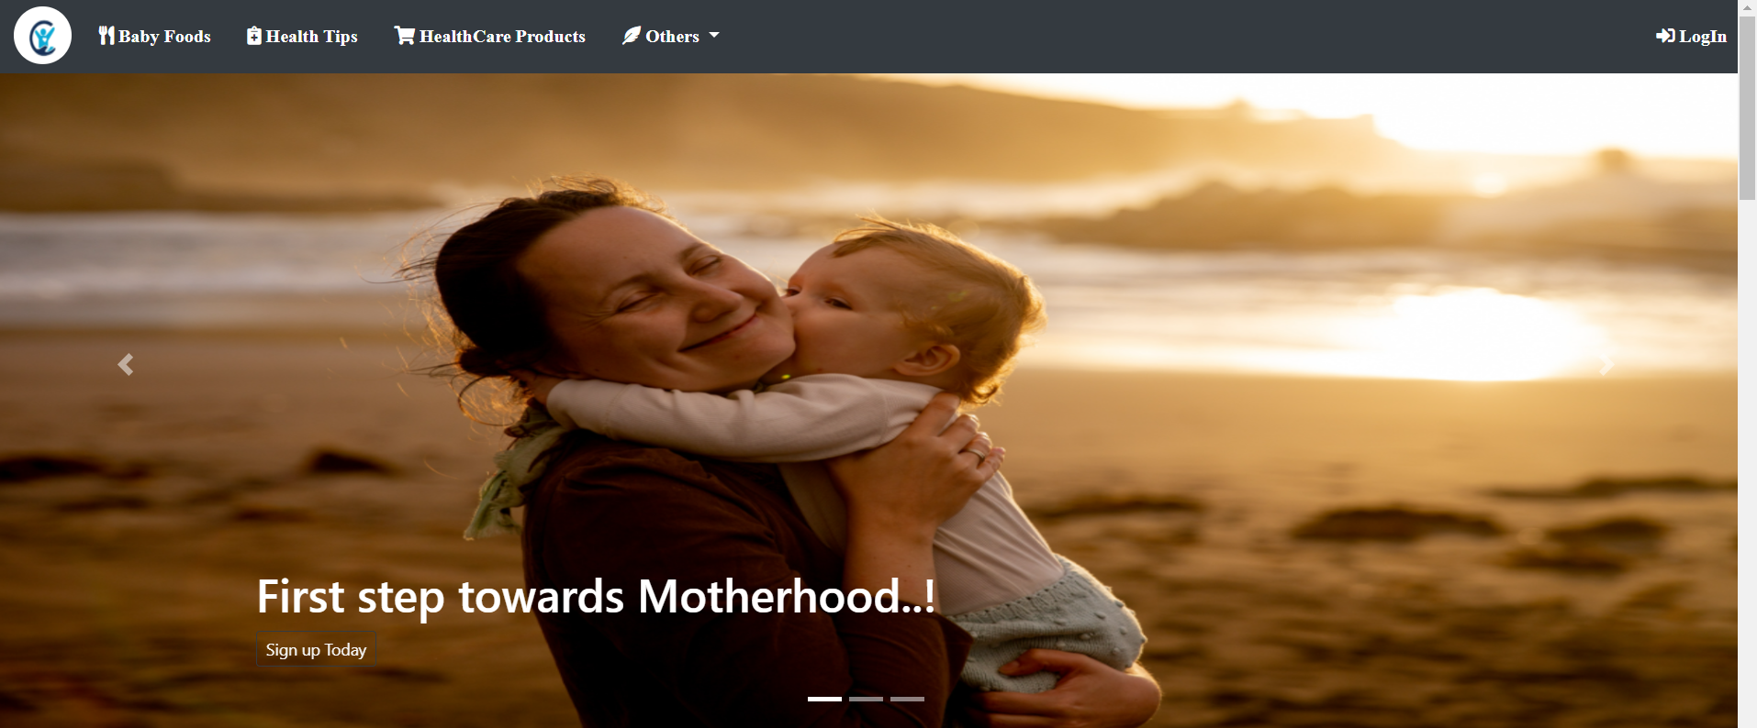

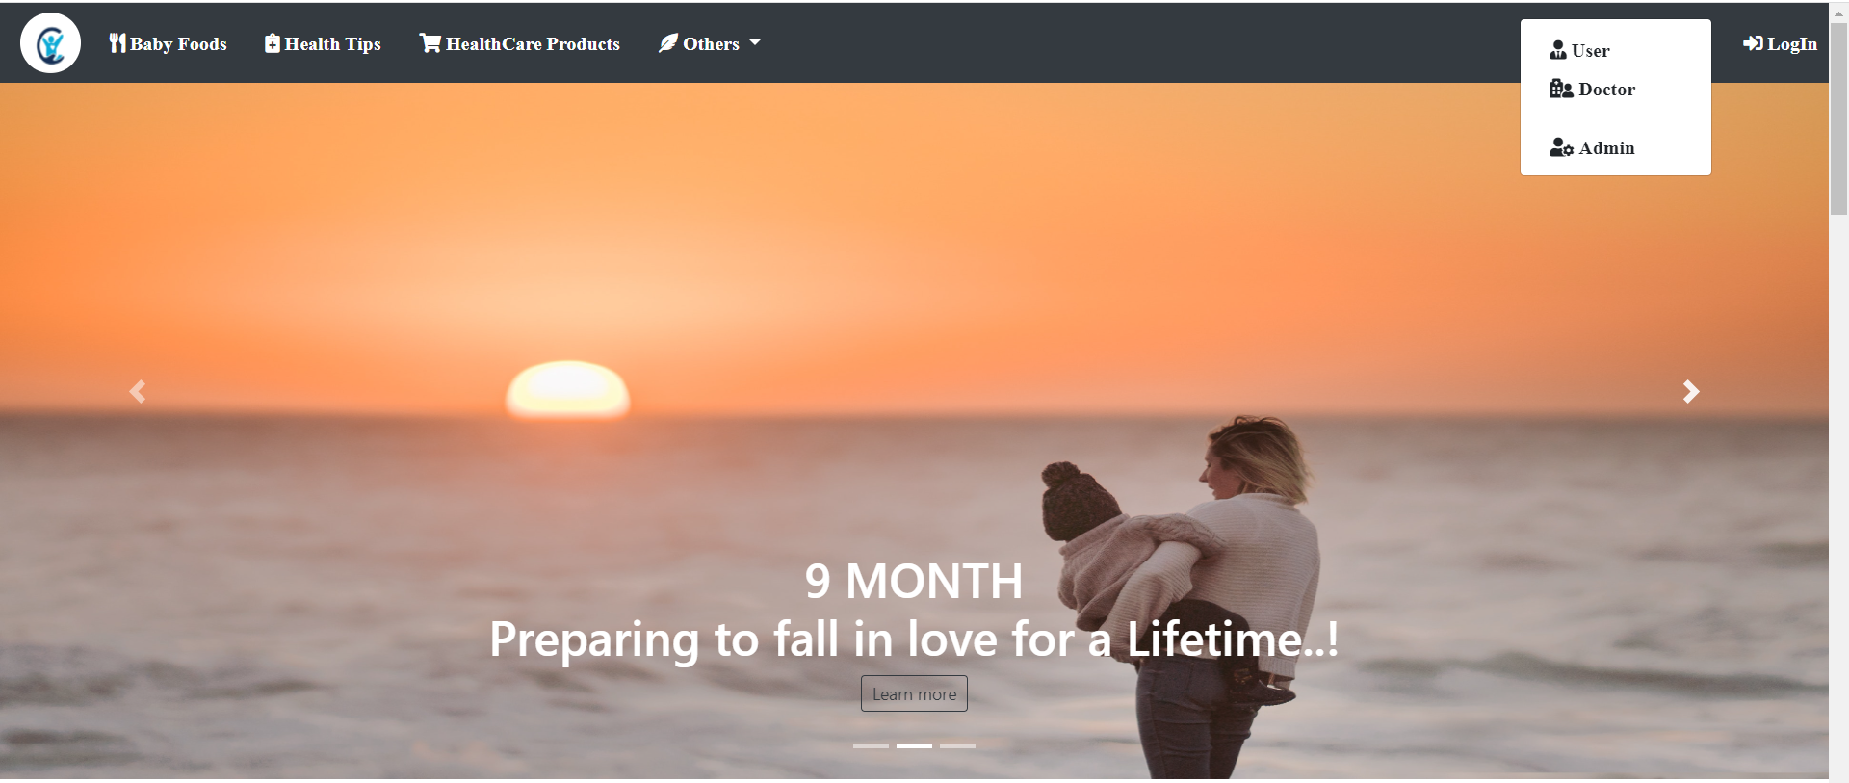

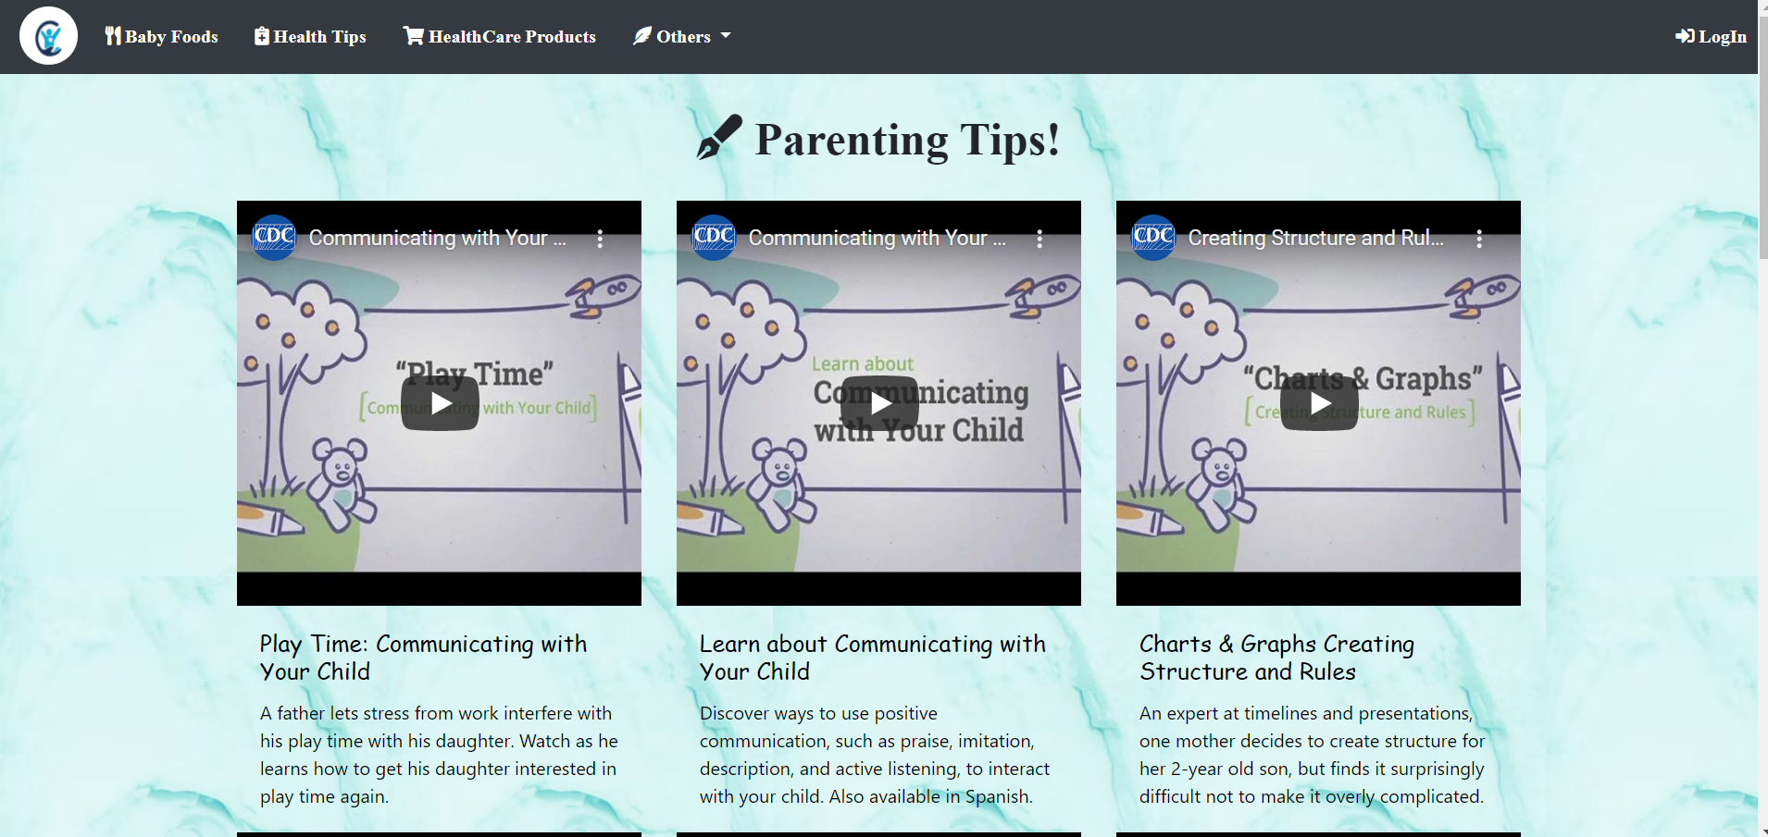

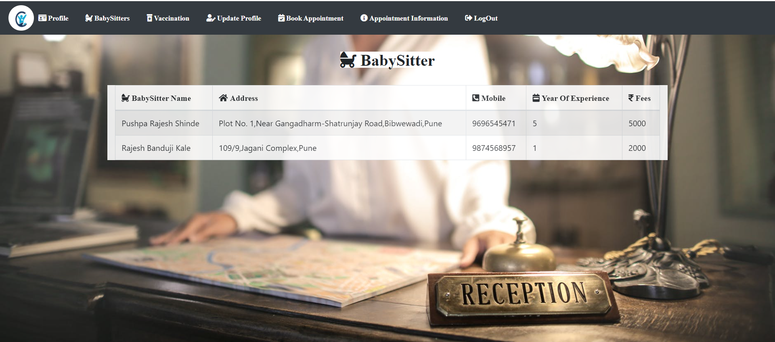

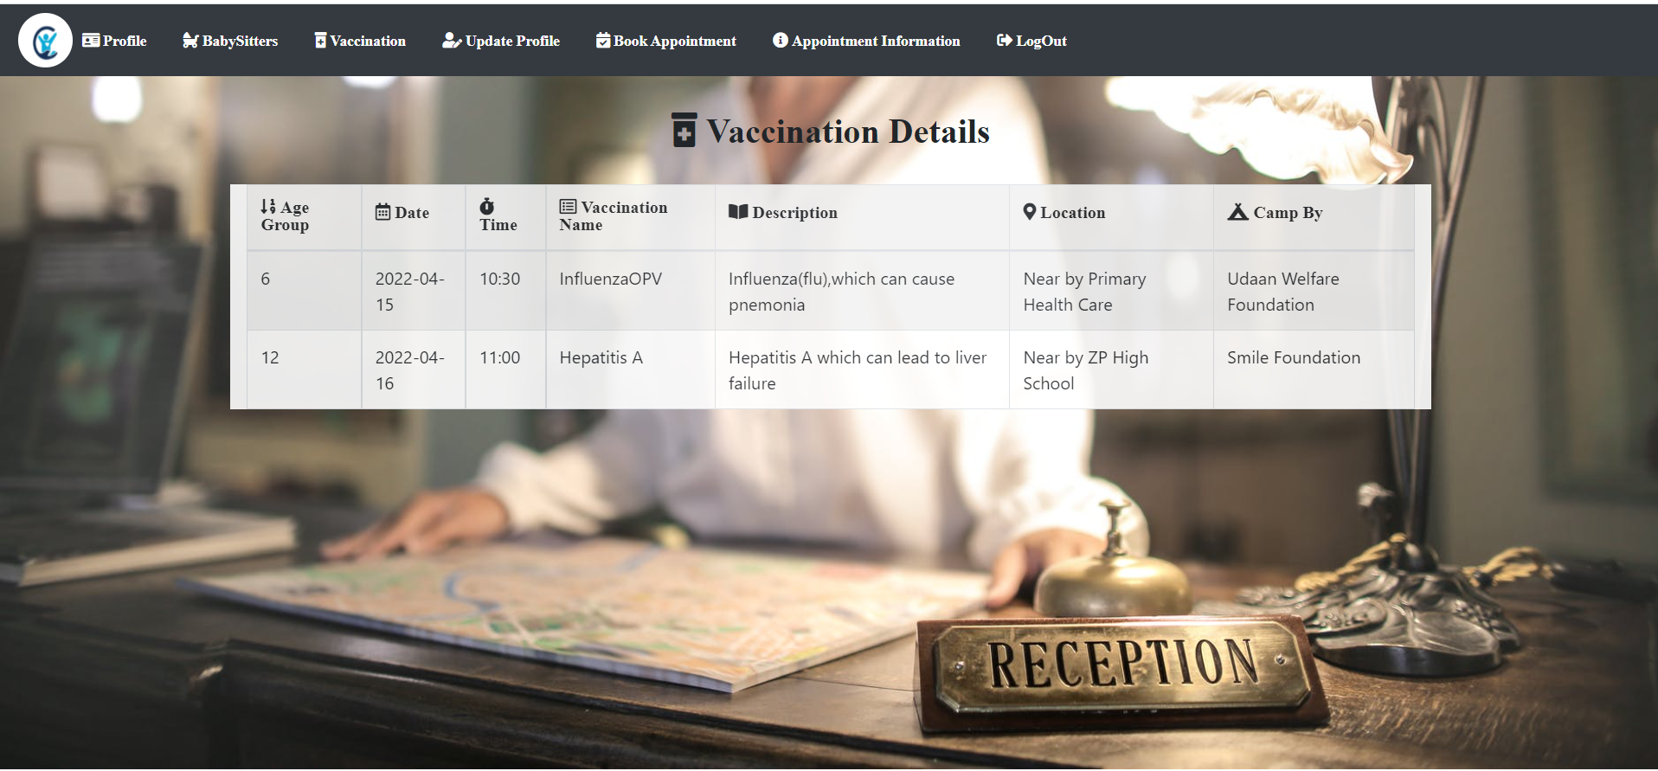

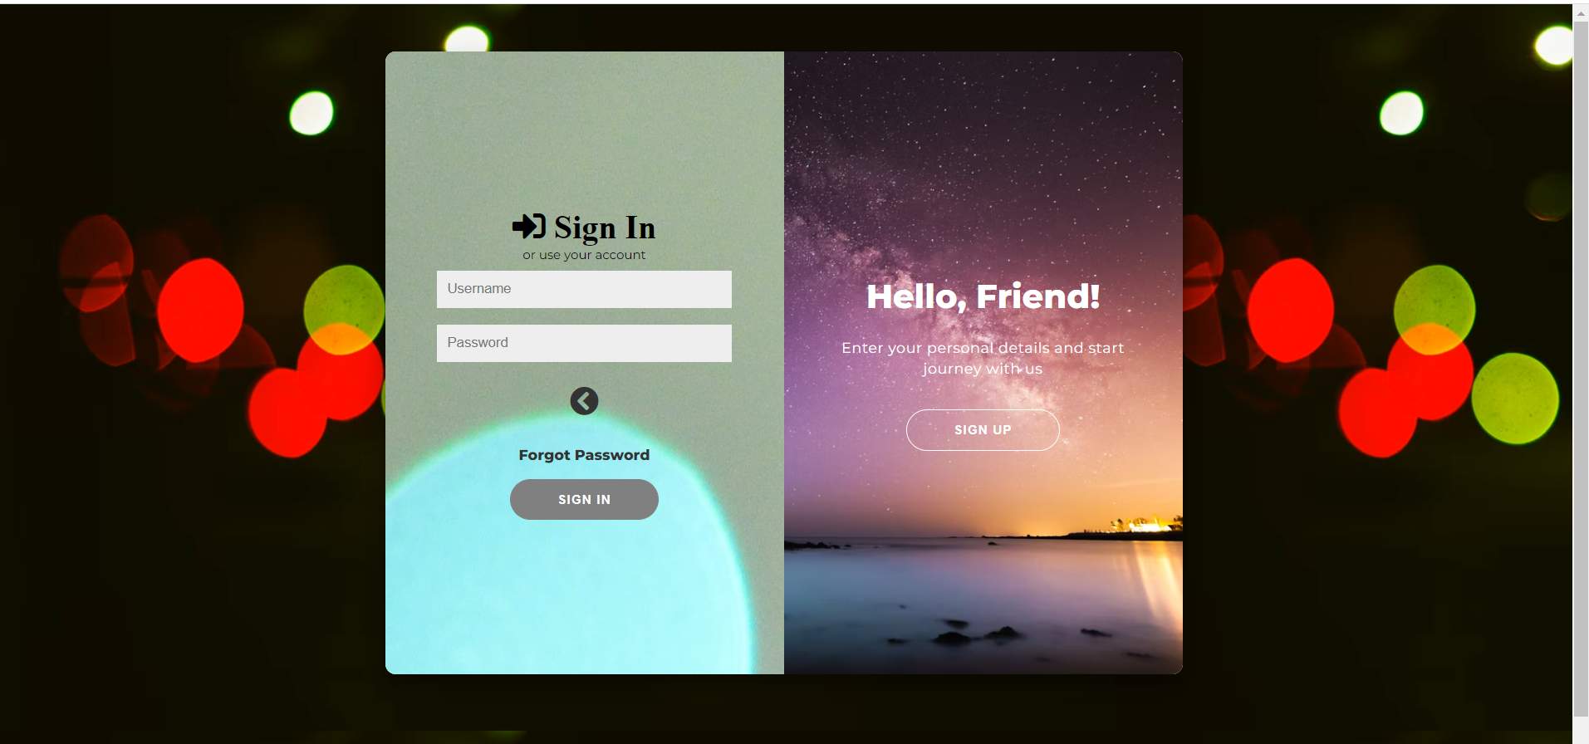

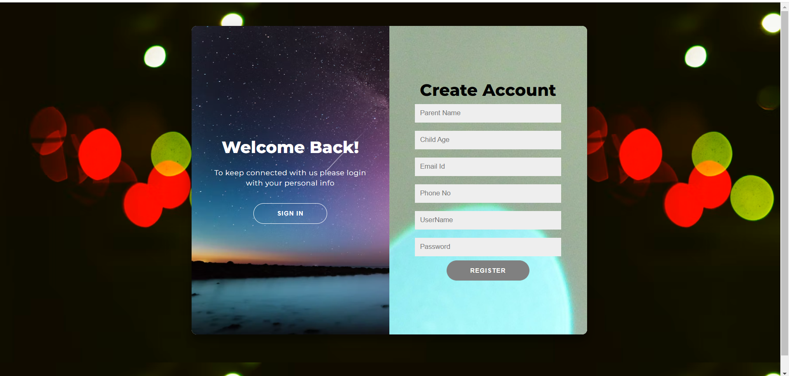

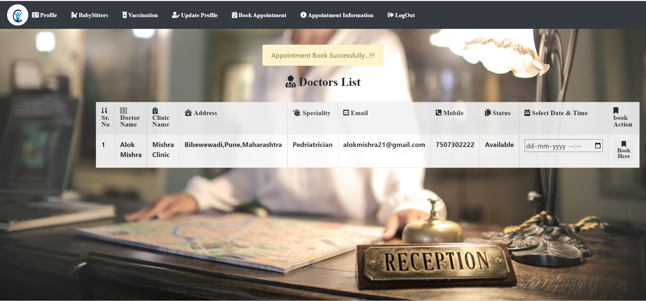

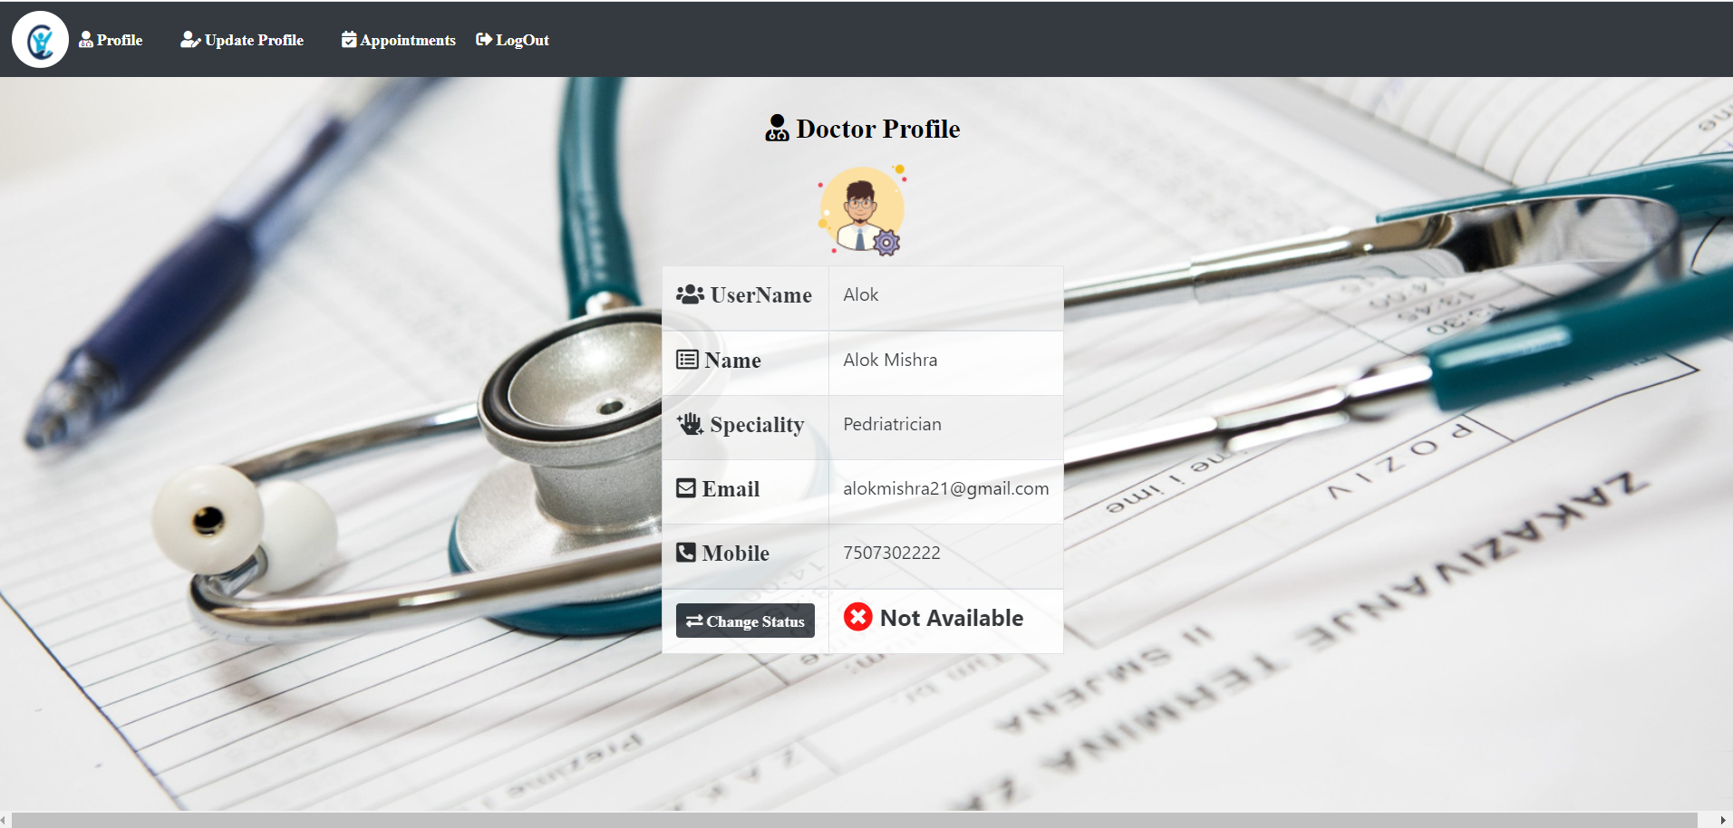

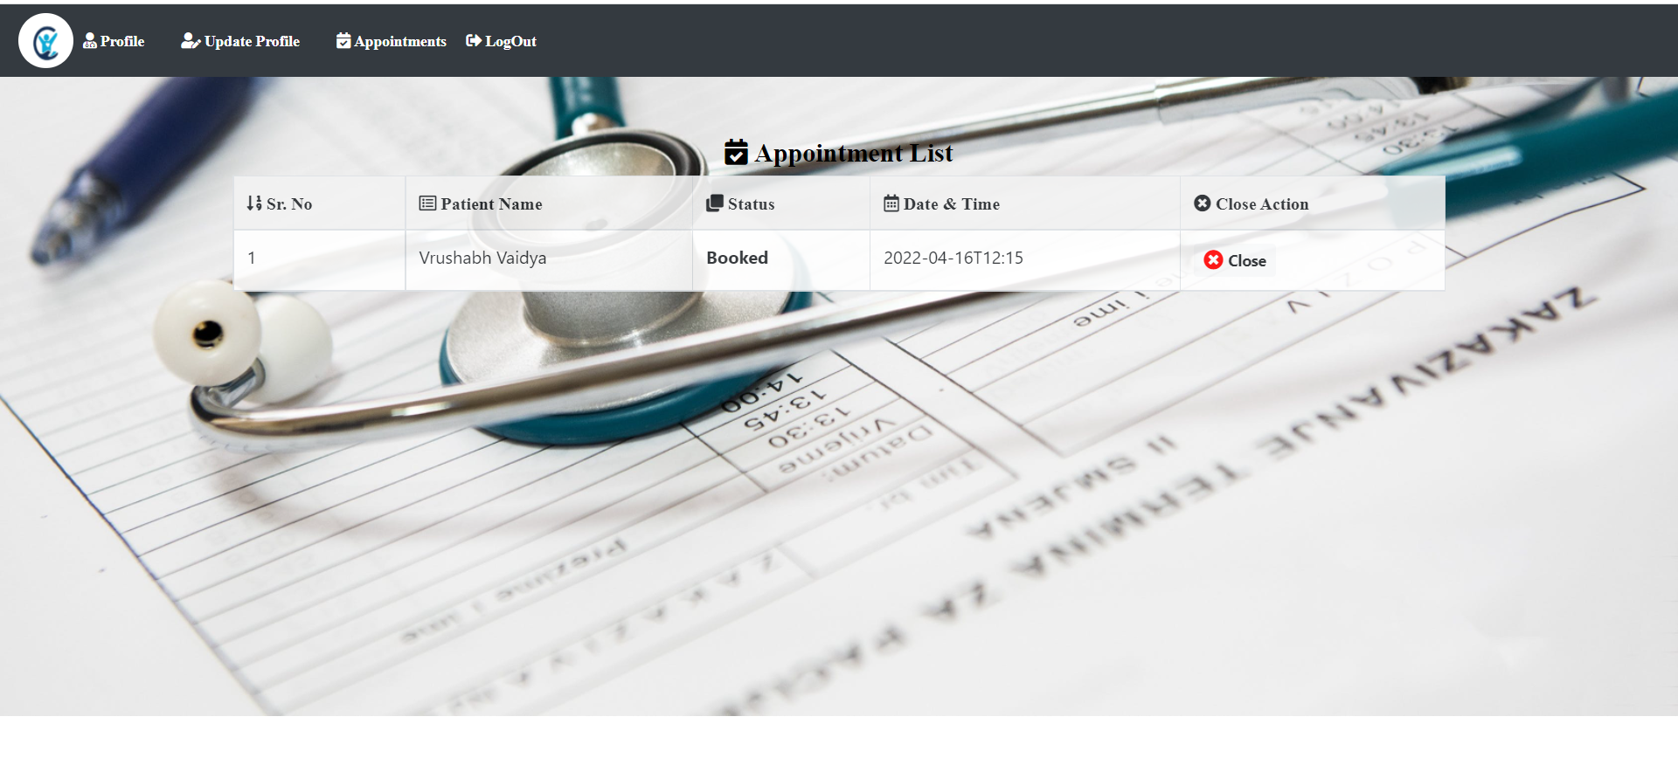

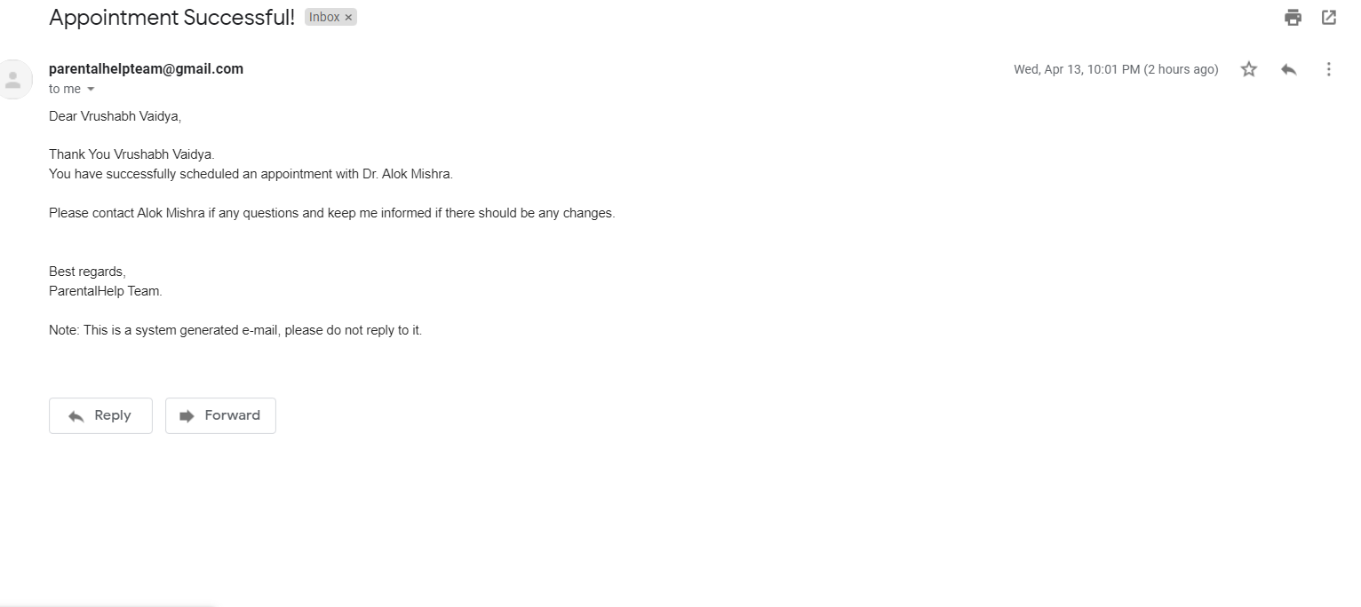

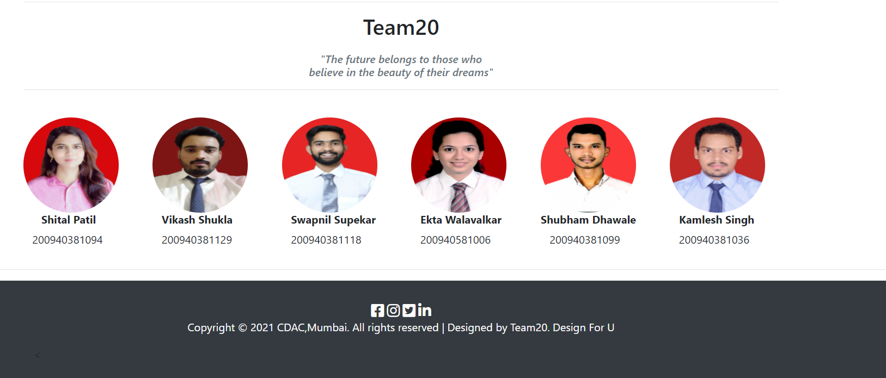

**Chapter 6**

**IMPLEMENTATION**

**6.1 Working of the project:**

* ***Registration:***

@PostMapping("/registered")

public ModelAndView create(String ptName, String age, String ptGmail, String ptMobile, String ptUsername,

String ptPassword) {

try {

// encrypt pass using hashPassword() method

ActionController actionController = new ActionController();

String encrpPassUser = actionController.hashPassword(ptPassword);

ModelAndView mv = new ModelAndView("register");

int ptAge = Integer.parseInt(age);

User user = new User(ptName, ptAge, ptGmail, ptMobile,

ptUsername, encrpPassUser);

userService.create(user);

mailSenderService.sendSimpleEmail(ptGmail, "Dear " + ptName +"," +"\n"+"\n"

+ "Congratulations! You have been registered successfully on BabyCare!! " +"\n" +"\n" +"Your login credentials are as follows:" +"\n"

+ "UserName : " + ptUsername + "\n" + "Password : " + ptPassword + "\n" +"\n" +"\n" + "Best regards," +"\n"+ "BabyCare Team." +"\n"+"\n"

+ "Note: This is a system generated e-mail, please do not reply to it.","Registration Successful!");

mv.addObject("patReg", 1);

return mv;

} catch (Exception e) {

ModelAndView mv = new ModelAndView("register");

mv.addObject("patReg", 0);

return mv;

}

}

* **Mailsender:**

@Service

public class MailSenderService {

@Autowired

private JavaMailSender mailSender;

public void sendSimpleEmail(String toEmail, String body, String subject) {

SimpleMailMessage message = new SimpleMailMessage();

message.setFrom("babycare578@gmail.com");

message.setTo(toEmail);

message.setText(body);

message.setSubject(subject);

mailSender.send(message);

System.out.println("Account Verification Mail Send Successfully...!!!");

}

}

* **Appointment:**

@GetMapping("/aptBooking")

public ModelAndView aptBooking(String appdate, String ptid, String drid) {

User user = userService.getSingleUser(ptid);

Doctors doctors= doctorService.getDoctor(drid);

List<Doctors> drList = doctorService.drList();

appointmentService.aptBooking(appdate, ptid, drid);

ModelAndView mv = new ModelAndView("bookAptShowDrList");

mv.addObject("user", user);

mv.addObject("drList", drList);

mv.addObject("b", 1);

System.out.println("appointment booked succesfully");

String Doc_mail=doctors.getDrEmail();

String email=user.getPtGmail();

String name=user.getPtName();

String doc_name=doctors.getDrName();

mailSenderService.sendSimpleEmail(email, "Dear " + name +"," +"\n"+"\n"+

"Thank You " + name +"." +"\n"+"You have successfully scheduled an appointment with Dr. "+ doc_name+"."+ "\n" +"\n" +

"Please contact "+ doc_name + " if any questions and keep me informed if there should be any changes."+ "\n" +"\n" +"\n" + "Best regards," +"\n"+ "BabyCare Team."+

"\n" +"\n" +

"Note: This is a system generated e-mail, please do not reply to it.","Appointment Successful!");

mailSenderService.sendSimpleEmail(Doc_mail, "Dear Dr. " + doc_name +"," +"\n"+"\n"+

"\n"+"You have an appointment with "+name+"."+ "\n" +

"Please contact "+name+ " if any questions and keep me informed if there should be any changes."+ "\n" +"\n" +"\n" + "Best regards," +"\n"+ "BabyCare Team."+

"\n" +"\n" +

"Note: This is a system generated e-mail, please do not reply to it.","Appointment Successful!");

mv.addObject("patReg", 1);

return mv;

}

**Chapter 7**

**TESTING**

**7.1 Test cases :**

|  |  |  |  |  |  |  |
| --- | --- | --- | --- | --- | --- | --- |
| **Test Id** | **Item to be Tested** | **Steps** | **Input** | **Actual Output** | **Expected Output** | **Pass/Fail** |
| **1** | **User Id** | **User enters user Id** | **User Id** | **Display Success** | **Display Message successful** | **Pass** |
| **2** | **System check for proper username and password entered by users** | **System compares the data entered by user and the entered data in database** |  |  |  |  |
|  |  | **If username and password is valid** |  | **Make Connection** | **Make connection** | **Pass** |
| **If username and password is invalid** |  | **Report invalid user id** | **Report error** | **Pass** |
| **3** | **System checks whether details of user are entered as per the format** | **System checks the data entered by user is in valid form or not.** |  |  |  |  |
|  |  | **If valid** | **User entered data** | **Entered in database** | **Entered in database** | **Pass** |
|  |  | **If invalid** | **User entered data** | **“Invalid Data” message will be printed** | **“Invalid Data” message will be printed** | **Pass** |

**7.2 Type of Testing used**

**Alpha Testing:-**

Alpha testing allows the team to test the software in a real-world environment. One of the reasons to

do alpha testing is to ensure the success of the software product. Alpha testing validates the quality,

functionality of the software, and effectiveness of the software before it released in the real world. It is

the most common type of testing used in the Software industry. The objective of this testing is to

identify all possible issues or defects before releasing it into the market or to the user.

**Chapter 8**

**Results and Discussions**

The idea is to help people find the best services easily and provide the large base of individuals and small businesses and healthcare professionals with a platform to manage and grow their client network.BabyCare is a platform that aims to effortlessly connect and serve a large local base of individuals with healthcare professionals.The main scope of this project is to provide Childcare Services at your ease and also on your doorstep, by providing trusted quality products and professionals .One stop for all your baby’s care.Our aim is to connect customers to professionals with ease ,also providing required healthcare products at their doorstep.

**Chapter 9**

**Conclusions**

In today’s fast growing and busy world ,every parent looks for an easy convenient and at the same time professional healthcare and childcare service for their loved ones.Finding everything at one spot is the main thing which everyone looks for in today’s busy life.Providing trusted quality service was the main motto of babycare management system ,so we came up with this idea as our platform provides major facilities such as Healthcare professionals and vaccination services at one stop .We hope this platform will help users find everything they need about childcare ,Working on this project was fun and insightful at the same time as we got to learn a lot of thing about spring.

**Appendix**

* MySQL is an open-source relational database management system (RDBMS).
* Spring Boot is an open source Java-based framework used to create a micro Service.
* Java Persistence API. It’s a specification which is part of Java EE and defines an API for object relational mappings and for managing persistent objects.
* Eclipse is an integrated development environment (IDE). Eclipse is written mostly in Java and its primary use is for developing Java applications.
* Visual Studio Code is a free source-code editor made by Microsoft for Windows, Linux and macOS.

**Acknowledgements**

We take this opportunity to express our heartfelt gratitude towards the CDAC Mumbai that gave us an opportunity for presentation of our project in their esteemed organization. With immense pleasure we would like to present this report on the project assignment of. We are thankful to all that have helped us a lot for successful completion of this project and for providing valuable guidance throughout .So we take this opportunity to thank those people who helped us to make this project and the report successfully. We give most sincere guide **Mr. Rohan Rakhunde** and **Mr. Kiran Ulgmude** who has always been guiding, encouraging and motivating force. He has provided us with valuable guidance at each and every phase. It has been learning experience, which we will always cherish in our heart. We would also like to express gratitude towards **Mr. Abhijeet Wagh** Sir for his timely suggestions .It is our proud privilege to express deep sense of gratitude for his comment and kind permission to complete this project. We would also like to thank our parents who provided their wishful support for our project completion successfully. And lastly we thank to our all friends who were directly or indirectly related to our project work.